Day 11 - 23.06.25

Assignment

Section A: Basic Understanding (Short Answer Questions)
1) What is a Python package? How is it different from a module?
A package is a folder that contains one or more Python files (modules) and an __init__.py file.
A module is just a single Python file (like math.py or my_module.py).
So:
- module = file
- package = folder of modules

2)What is the purpose of __init__.py in a package directory?
It tells Python, “Hey, this folder is a package!”
Also, you can use it to run setup code or define what gets imported when using from package import *.

3)What happens when you use from package import * in Python?
It imports everything listed in the package’s __all__ variable (defined in __init__.py).
If __all__ is not defined, nothing gets imported by default.

4)What is the effect of defining __all__ in a package’s __init__.py file?
It controls what gets imported when someone uses from package import *.
Example: If __all__ = ['basic_ops'], then only basic_ops will be imported

5)How can you create and use a subpackage in Python?
Just make a folder inside your package with its own __init__.py and modules.
Then import like:
from main_package.subpackage import module_name

Section B: Coding-Based Questions
6)Create a package called math_utils with the following modules:
basic_ops.py – containing functions for add, subtract
advanced_ops.py – containing functions for power and factorial
Demonstrate how to import and use all functions using from math_utils import *.
Folder structure:
math_utils/
├── __init__.py
├── basic_ops.py
└── advanced_ops.py

math_utils/basic_ops.py
def add(a, b):
return a + b
def subtract(a, b):
return a - b

math_utils/advanced_ops.py
def power(a, b):
return a ** b
def factorial(n):
if n == 0:
return 1
return n * factorial(n - 1)

math_utils/init.py
from . import basic_ops
from . import advanced_ops
__all__ = ['basic_ops', 'advanced_ops']

main.py (to use it):
from math_utils import *
print(basic_ops.add(2, 3))
print(advanced_ops.factorial(5))

7) Write Python code to show how intra-package references work when module_a.py imports a function from module_b.py inside the same package.
Folder: my_package/
my_package/
├── __init__.py
├── module_a.py
└── module_b.py

module_b.py
def greet():
return "Hello from module B"

module_a.py
from .module_b import greet # <- relative import
def call_greet():
return greet()

8) Create a package shapes with a subpackage area. In area, create modules circle.py and rectangle.py. Show how to import area_of_circle from circle.py in rectangle.py using relative import.
Structure:
shapes/
└── area/
├── __init__.py
├── circle.py
└── rectangle.py

circle.py
def area_of_circle(radius):
return 3.14 * radius * radius

rectangle.py
from .circle import area_of_circle # <- relative import

def show_circle_area():
print("Circle area:", area_of_circle(5))

9)Modify your package math_utils to include __all__ = ['basic_ops'] in the __init__.py. What will happen if you run from math_utils import * after that?
from . import basic_ops

__all__ = ['basic_ops']

from math_utils import *

Only basic_ops will be imported. advanced_ops won't be available unless you import it manually:
from math_utils import advanced_ops

Exception Handling – Question Paper

Section A: Basic Try-Except (2 marks each)
1. Write a program to divide two numbers entered by the user. Handle ZeroDivisionError using try-except.
try:
a = int(input("Enter first number: "))
b = int(input("Enter second number: "))
result = a / b
print("Result:", result)
except ZeroDivisionError:
print("You can't divide by zero!")
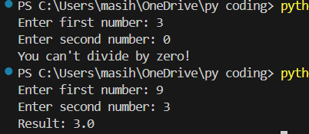
2. Write a program to convert a string to an integer. Handle ValueError if the input is not a valid number.
try:
user_input = input("Enter a number: ")
num = int(user_input)
print("You entered:", num)
except ValueError:
print("That's not a valid number!")
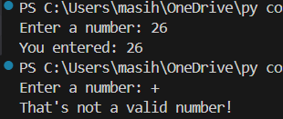
3. Accept two numbers from the user and perform addition. Use try-except to handle invalid input types.
try:
x = int(input("Enter first number: "))
y = int(input("Enter second number: "))
print("Sum is:", x + y)
except ValueError:
print("Please enter valid numbers!")
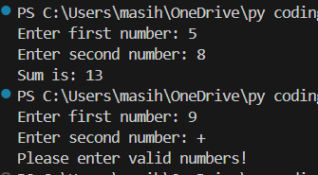

4. Write a program to read an element from a list using an index entered by the user. Handle IndexError.
my_list = [10, 20, 30, 40, 50]
try:
idx = int(input("Enter index (0 to 4): "))
print("Element is:", my_list[idx])
except IndexError:
print("Index out of range!")
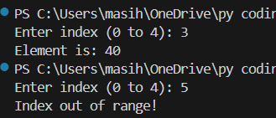
Section B: Try-Except-Else (4 marks each)
5. Create a program that accepts a number from the user and prints its square. Use try-except-else to handle ValueError and ensure successful computation is shown only if there's no error.
try:
num = int(input("Enter a number: "))
except ValueError:
print("That's not a valid number!")
else:
print("Square is:", num ** 2)
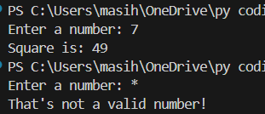
6. Write a program to open a file and read contents. Use try-except-else to handle FileNotFoundError.
try:
file = open("sample.txt", "r")
except FileNotFoundError:
print("File not found!")
else:
content = file.read()
print("File content:\n", content)
file.close()
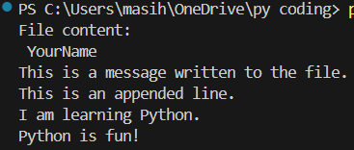
7. Write a Python program to convert a number to its binary format. Use try-except-else to handle any invalid input.
try:
num = int(input("Enter a number: "))
except ValueError:
print("Not a valid number!")
else:
print("Binary is:", bin(num))
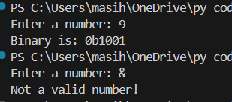

Section C: Try-Finally (5 marks each)
8. Write a program that opens a file and ensures it gets closed, whether or not an exception occurs. Use try-finally.
file = None
try: file = open("sample.txt", "r")
data = file.read()
print(data)
except FileNotFoundError:
print("File not found.")
finally:
if file:
file.close()
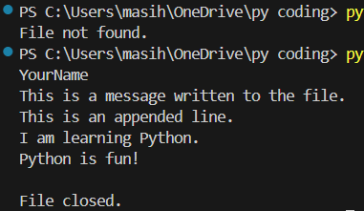
print("File closed.")

9. Simulate a login process where the user input is handled in a try block and a log message is printed in finally regardless of success or failure.
try:
username = input("Enter username: ")
password = input("Enter password: ")
if username == "Raja" and password == "1234":
print("Login successful!")
else:
print("Wrong username or password!")
finally:
print("Login attempt finished.")
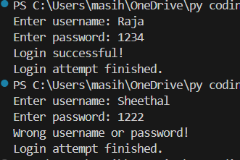
10. Write a program that divides two numbers, catching errors with try-except, and printing a clean-up message using finally.
try:
a = int(input("Enter number 1: "))
b = int(input("Enter number 2: "))
print("Result:", a / b)
except ZeroDivisionError:
print("Cannot divide by zero.")
finally:
print("Program has finished running.")
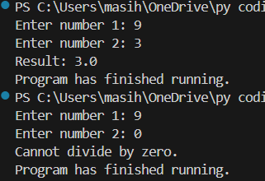

Section D: Combined Exception Handling (6 marks each)
11. Create a program that handles multiple exceptions: ZeroDivisionError, ValueError, and always prints "Execution complete" using finally.
try:
x = int(input("Enter number 1: "))
y = int(input("Enter number 2: "))
result = x / y
print("Result:", result)
except ZeroDivisionError:
print("Can't divide by zero!")
except ValueError:
print("Please enter valid numbers.")
finally:
print("Execution complete.")
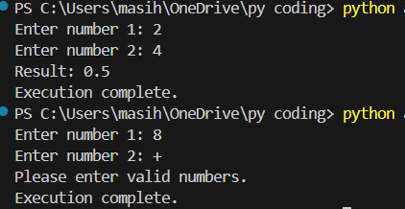

12. Write a program to simulate bank withdrawal. Use try-except-else-finally to handle incorrect amount input, and always print a message whether the transaction succeeded or failed.
balance = 5000

try:
amount = int(input("Enter amount to withdraw: "))
if amount > balance:
print("Not enough balance.")
else:
balance -= amount
except ValueError:
print("Invalid amount entered!")
else:
print("Withdrawal successful. Remaining balance:", balance)
finally:
print("Transaction attempt complete.")
